COUNTERFEIT PRODUCT DETECTION USING QUANTUM PROOF-KNUCT BLOCKCHAIN

File Structure:

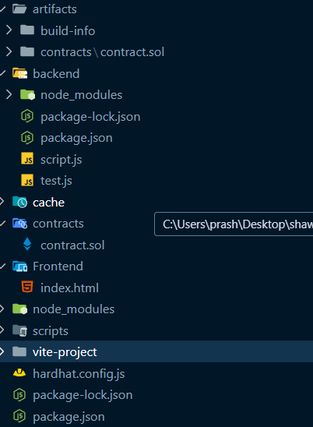

Technology Stack:
 | Our Model | In Knuct
Blockchain | Hardhat
Server | Express.js
Backend | Node.js
Frontend | React.js/HTML
Smart Contracts | Solidity

Results:

